Northern Illinois Assn of Teachers of Mathematics (NIATM)
Northern Illinois Association of Teachers of Mathematics (NIATM), is an associate affiliate of the National Council of Teachers of Mathematics (NCTM). www.facebook.com/niatmath/

We host 4 professional development sessions each year. These sessions are a wonderful opportunity to network with other area schools, and are open to current and retired teachers and college students, as well as other math enthusiasts. We hope to see you this year!

All sessions will be held at Rockford University in the Faculty Dining Room (2nd Floor of Burpee Student Center). 5:30 - 6:15 PM Dinner ($10) 6:15 - 7:15 PM Session & Questions
Coming? RSVP to: Patty McHugh(pmchugh@district100.com) or www.facebook.com/niatmath/

2025-2026 membership fees: Please contact Becky Reynolds (breyno@hononegah.org).
$20 regular $10 student $10 retired
………………………………………………………………………………………………………………………
Session 4 - Wednesday, April 22 Aimee Hart & Devan Castellano
- New Trier High School, District 203, Winnetka

Geometry & Construction: You don’t have to build a house: Although there are some very cool classes called Geometry in Construction that build a house while learning geometry, we have focused on smaller projects tied to the Geometry curriculum at our school. Geometry, Design and Construction is offered at all levels and attracts a variety of students. We cover our traditional geometry curriculum, and students use the math they learn to design and build small and large projects. We will give an overview of the course, examples of the mathematics in action and how to choose projects when you have limited space and budget.

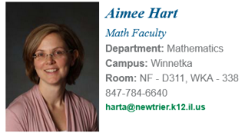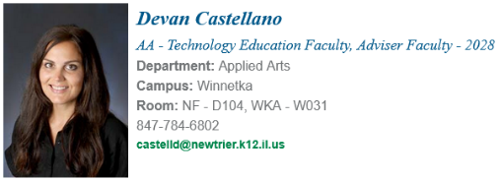
Aimee Hart began her teaching career 29 years ago. She has worked for both public and private schools in Chicago and at an international school in Rome, Italy. This is her 20th year teaching math at New Trier High School. She has served on the board of the Metropolitan Math Club of Chicago and volunteers as a lead teacher for Math Circles of Chicago.

Devan Castellano is a licensed architect and LEED AP with 25 years of experience in
architecture. For the past seven years, she has taught Architecture and Urban Design,
Engineering and Geometry, and Design and Construction in the Applied Arts department at
New Trier High School, where she emphasizes community collaboration and real world
engagement. Her background includes higher education teaching, research, and sustainability
consulting, and she currently leads dual credit courses at New Trier while operating a small
solo architecture practice.
………………………………………………………………………………………………………………………

NIATM Business/Organizational Meeting – Thursday May 14
- 5:30 PM, Linos Restaurant, Rockford

Open to all members. We will determine officers, set business policies, determine speakers for the coming (2026-27) school year, and determine dates for NIATM events.
Please RSVP Patty McHugh or Becky Reynolds.

